Lucy and the Duck
Alan Kaylor Cline

The story told here is one of courage amidst horror – one teenager’s audacity in the face of terror. The heroine is actually not Lucy as the title may imply, but her elder sister Martha Jane. I have put Lucy in the title because the duck was hers (and because she is my great-grandmother).

May I first set the stage for our drama. Unfortunately, it is quite unpleasant. In the autumn of 1864, Generals Grant and Lee faced one another across a siege line that nearly surrounded Richmond and Petersburg. Lee realized the end was coming but there was a slim hope that the southern confederacy might still gain independence if Lincoln were to lose the election coming in November. To persist, however, Lee’s army needed food.

The source of the food was the Shenandoah Valley – 100 miles to the northeast. Partially to protect the valley and partially to threaten Washington, Lee sent General Jubal Early there in June. In response, Grant sent General Philip Sheridan in August with instructions to preclude any of the food from the valley reaching Lee’s army: “Such as cannot be consumed, destroy”. Sheridan’s own interpretation was that "The people must be left with nothing but their eyes to weep with over the war.” (As ruthless as he was in Virginia, Sheridan’s greater fame came later when he increased the level of his terror against the native people of the West. Whether he actually uttered “The only good Indian is a dead Indian” may never be proved but it certainly characterized his attitude.)

Lest anyone attempt to attach villainy to only one side in the tragedy, it should be added that on July 30, Early had burned the entire town of Chambersburg, Pennsylvania resulting in $2,000,000 worth of damage. Sheridan’s damage spread across four valley counties: in Rockingham County alone (having an 1860 population of about 23,000 and the scene of our story), he had 450 barns and 30 mills burned, eleven thousand animals killed or stolen, and more than eleven thousand tons of wheat, corn, and hay destroyed. Sherman’s devastation in Georgia exceeded Sheridan’s in the valley in total value but Sherman’s was less concentrated.

Sheridan’s instructions were that dwellings were to be saved but every barn was to be burned. An exception was that widows’ property was to be preserved. Another exception was that some houses were to be torched – those of the slave owners in particular often were lost. Thus, in spite of Sheridan’s original instructions, thirty-one dwellings were burned in Rockingham County.

Our story concerns one girl’s courage when confronted with this horror. The Dramatis Personae include:

Jacob and Margaret Byerly: 48 and 39 years old, respectively. They had four daughters and two sons living with them on a large and prosperous farm. They also owned a flour mill. (My great-great-grandparents).

Martha Jane Byerly: a nineteen year old daughter (our heroine).

Nanny: a middle-aged slave in the Byerly household.

Mary Frances (Fannie) Byerly: a seven year old daughter. (She later married James R. Lupton, the namesake of my grandfather Lupton Kaylor.)

Lucy Margaret Byerly: the youngest of the Byerly children – still a month shy of her fourth birthday. (My great-grandmother. She married Peter Cline Kaylor eighteen years later.)

Soldiers of Col. Daniel Macauley’s Third Brigade, Second Division, XIX Corps, United States Army: infantrymen from New York and Massachusetts.

A Duck: age and genealogy unknown.

The date is October 6, 1864. The story is quoted from John Heatwole’s The Burning - Sheridan in the Shenandoah Valley (Howell Press, 1999). His source was primarily writings and correspondence with John F. Byerly, Jr. The story is a delightful family legend – we may never know how accurate it actually is.

“One of the first farms visited by the infantry belonged to Jacob and Margaret Byerly, whose extensive holdings bordered the pike to the east. For two days they had watched homes burning across the wide fields and the pike, and they fully expected to be included in the destruction. Michael Shank's house, near the Pike Mennonite Church, had gone up in flames the evening before. On this morning, the 6th, the Byerlys saw the barns and outbuildings of neighbors toward Mount Crawford sending black plumes of smoke heavenward as rain-dampened siding caught fire. As the drier framing timbers ignited, the color of the smoke changed to a dirty gray.

“The Byerly's eldest daughter, seventeen-year-old (sic) Martha Jane, took joy in her music but had played her concertina very little over the past couple of months. She, like so many who had believed Southern independence to be a real possibility, had come to realize that the end of the war was in sight and that it was not going to be what had been hoped for or imagined. And it was no longer a war of principle fought in far fields—this very morning it stalked up the lane in the guise of blue-clad infantrymen. Martha Jane clutched the concertina to her breast; it was her most prized possession, and she was not about to let it go without a fight. Other valuables had already been hidden away; a slave, Nanny, had even contrived to secure a five-pound sack of sugar under her skirts.

“The officer in charge sent men to round up the livestock while the burning squads made their preparations. Besides the smaller outbuildings on the flats along the creek, two fine, large barns faced each other across the yard. The officer himself entered the Byerly home with a few of his men to announce his intent to destroy it. The family was told to get out. Byerly begged for relief, but it seemed as if his entreaties fell on deaf ears. Finally, having resigned himself to the loss, he told the unrelenting officer that he would stay and bear witness from the yard. Whether it was the father's fervent pleas, the sight of the distraught children, or something else that finally touched the officer will never be known, but he unexpectedly rescinded the order—the house was saved.

“Martha Jane stood behind the house and watched in horror as the granary, pens, comcribs, smokehouse, and barns were engulfed in flames. The roar of the fire mixed with the cries of frightened animals as some of the soldiers chased stray pigs and sheep while others tried to hold the rest together in a little herd. Despite the chaos, the stunned girl focused on a single animal, a special pet belonging to her younger sisters, Fannie and Lucy—a little duck now waddling back and forth in great agitation. The sight of the frantic duck stirred Martha Jane into action. With tears streaming down her cheeks, she moved toward the men, crying out that the duck was a pet and should not be harmed.

“Several of the soldiers, who probably were not much older than Martha Jane herself, laughed and elbowed one another in the ribs. One of them picked up the bird and told her teasingly that if she were to play them a tune, and if they liked it, she just might get the duck back. She wiped the tears from her eyes and slipped her hands through the straps of the concertina. With great deliberation she pulled air into the squeezebox, placed her fingers on the buttons, paused a double beat to summon up her courage, and then began to play with great passion. When the first few notes of the popular Southern anthem "Dixie" rose above the din, the soldiers were astonished. For a few long moments they seemed to be as stunned as Martha Jane had been. Finally the soldier holding the duck laughed good-naturedly and offered it to the plucky musician. She stopped playing immediately, pulled the quacking duck into the crook of her arm, and ran with it to the house.”

The story has several happy endings not the least of which for the duck. The house was not burned. Nanny, having come into contact with the Federal soldiers got her freedom. (Whether she left with the soldiers, left shortly after the war, or ever left the Byerly household at all is not known.) However, perhaps in partial mitigation of the guilt of slave ownership, Jacob Byerly accepted the position as the chairman of the Rockingham County board of supervisors for the Freedmen’s Bureau after the war. Thus, he went from being a slave owner to being the primary protector of freed slaves in the county.
Photographs

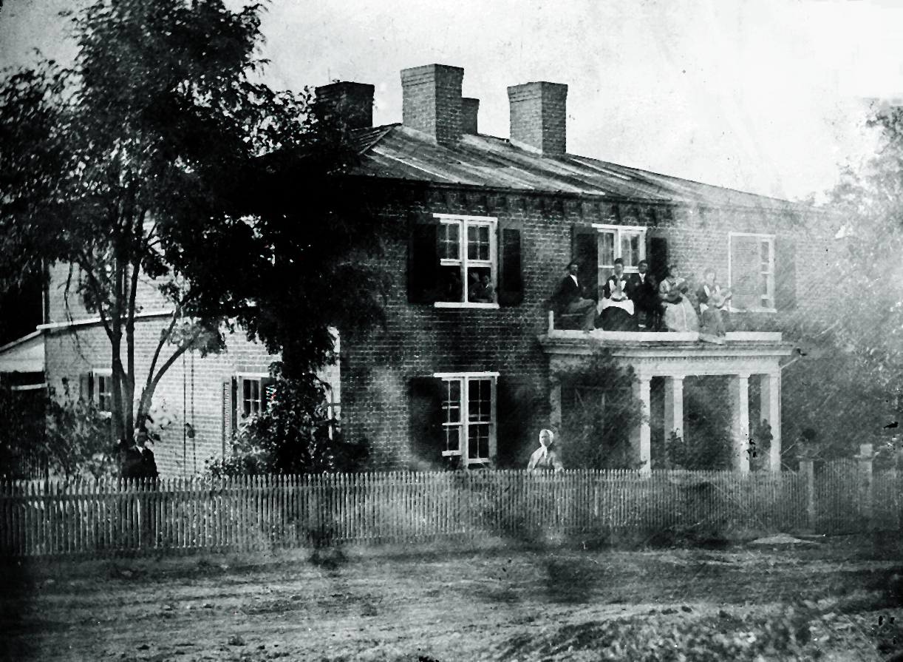

The Byerly House in about 1875. Jacob is to the left in front of a tree.
Margaret is in the middle near the fence. Lucy is on the porch roof
wearing a white apron. To her left is her husband Peter Cline Kaylor.

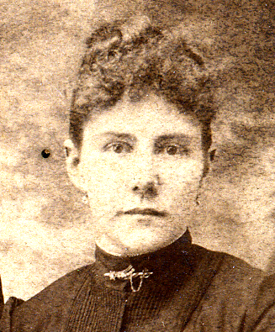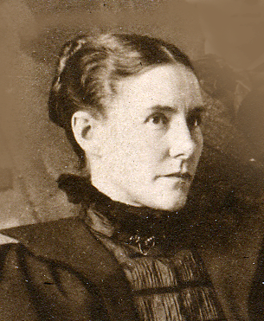
Lucy at 22 Lucy at 28 Lucy at 35

Lucy’s Namesake

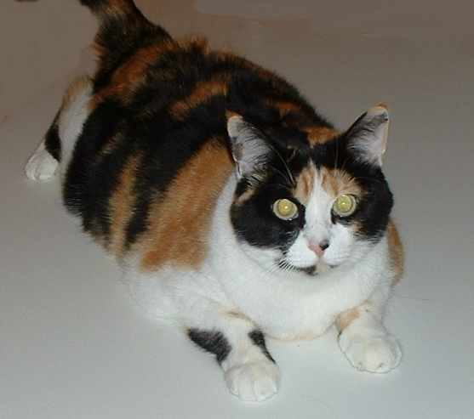

Lucy Margaret Byerly Kaylor KittyCat Cline
at 6
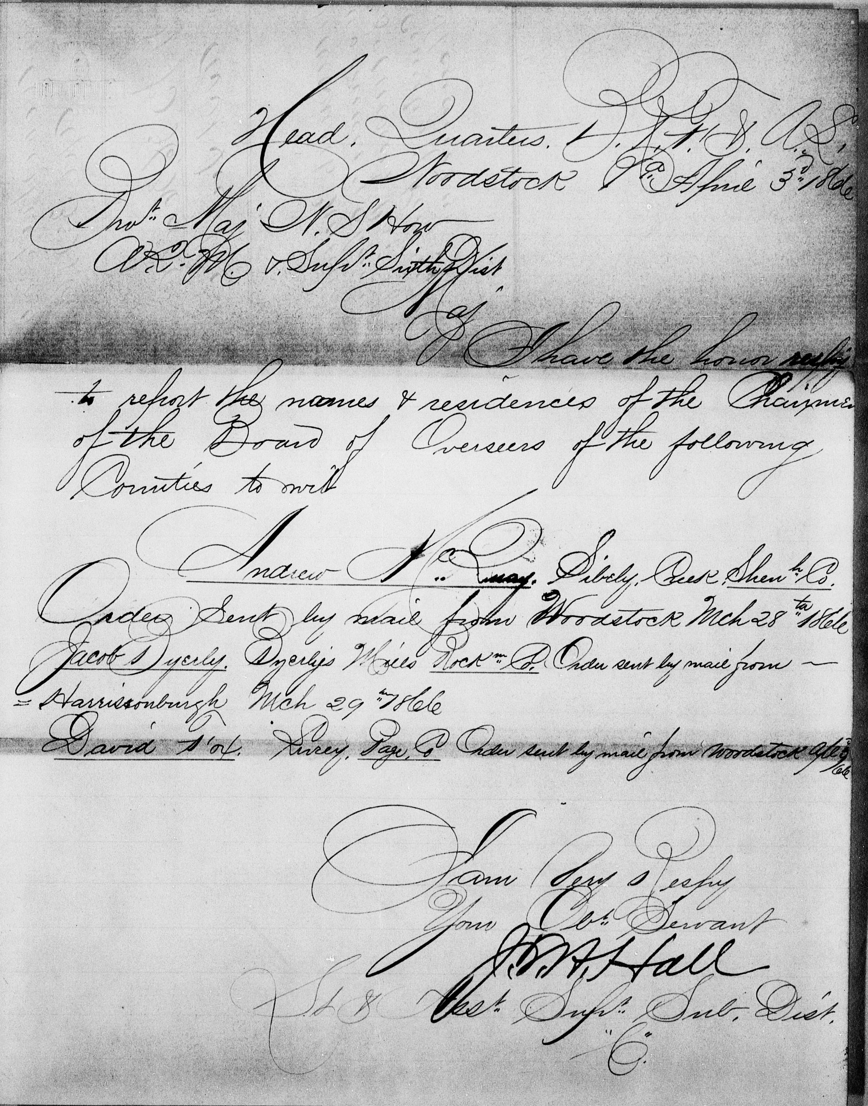

Order reflecting Jacob Byerly’s appointment as Chairman of the Board of Supervisors of the Freedmen’s Bureau in Rockingham County. April 3, 1866

