A Spring/Damper Suspension ODE Problem
Due Friday, December 6 by 12 noon

(From Recktenwald Problem 26, pp732-3)

The following is a simplified model of the suspension system of one wheel of an automobile.

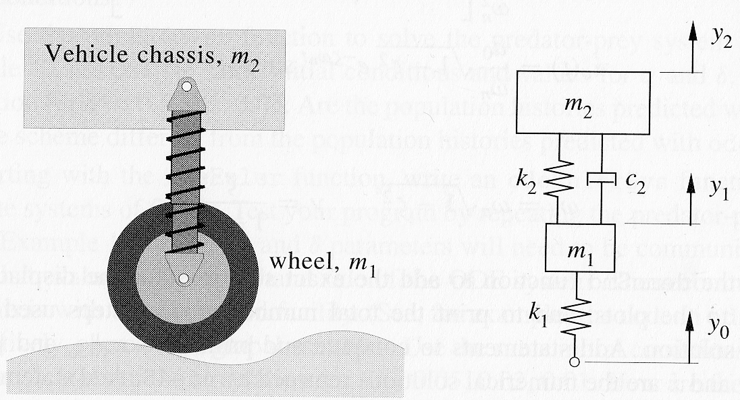

The input to the system is the time-varying displacement corresponding to changes in the terrain. The shock absorber is characterized by its spring rate and damping coefficient . Damping in the tire is neglected. (There is no term.)

Applying Newton’s law of motion and force balances to the wheel and vehicle chassis yields the following system of equations:

- Convert these two second-order equations into an equivalent system of first-order equations. (How many first-order equations are required?). Write a Matlab function yp = spring (t, y, m, k, c) that takes as input the time t, a column array y, and the constants m, k, and c (as arrays). Imbed the forcing function

We construct the new array so and this
is implemented in the Matlab function:

function yp = spring (t, y, m, k, c)
yp = zeros(4,1);
yp(1) = y(3);
yp(2) = y(4);
yp(3) = (.05*sin(3*pi*t)-c(2)*(y(3)-y(4))-k(2)*(y(1)-y(2))-k(1)*y(1))/m(1);
yp(4) = (c(2)*(y(3)-y(4))+k(2)*(y(1)-y(2)))/m(2);

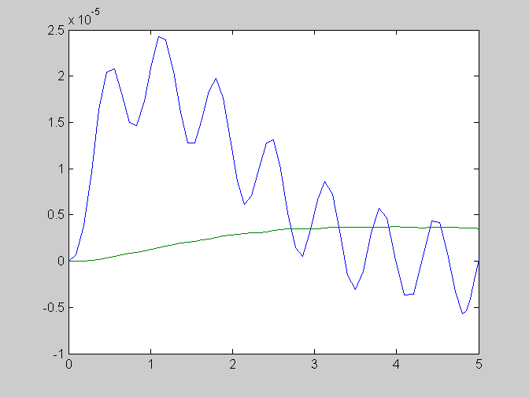
- Use Matlab function ode45 integration routine to solve this system on the time interval for and . Assume the system is at rest at (i.e., and ). Produce a plot that shows both and versus .

m = [110; 1900];
k = [136; 16];
c = [0; 176];
[t, y] = ode45 (@spring, [0 5], y0, [], m, k, c);
plot (t, y(:, 1), t, y(:, 2));

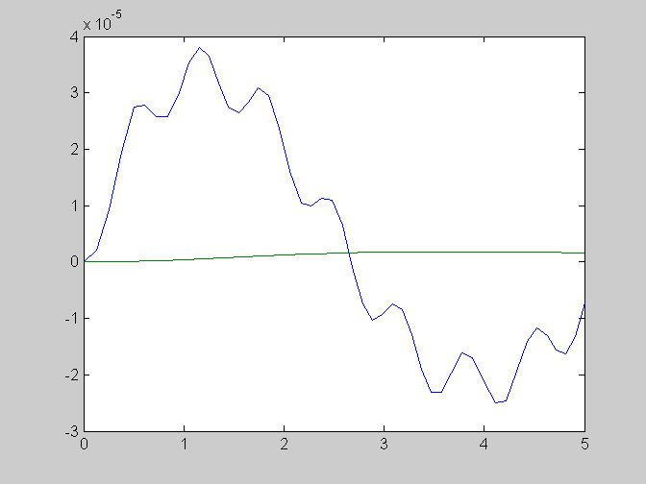
- Repeat the solution with reduced by a factor of 5.

C(2) = c(2)/5;
[t, y] = ode45 (@spring, [0 5], y0, [], m, k, c);
plot (t, y(:, 1), t, y(:, 2));

