Points off 1 2 3 4 4 Total off Net Score
CS 307 – Midterm 2 – Spring 2007

Name__________________________________________
UTEID login name _______________________________
TA's Name Alison Aparajit Vineet (Circle One)

Instructions:
- Please turn off your cell phones
- There are 5 questions on this test.
- You have 2 hours to complete the test.
- You may not use a calculator on the test.
- When code is required, write Java code.
- When writing methods, assume the preconditions of the method are met.
- In coding question you may add helper methods if you wish.
- After completing the test please turn it in to one of the test proctors and show them your UTID.

1. (2 points each, 30 points total) Short answer. Place you answers on the attached answer sheet.
  - If the code contains a syntax error or other compile error, answer “compile error”.
  - If the code would result in a runtime error / exception answer “Runtime error”.
  - If the code results in an infinite loop answer “Infinite loop”.

Recall that when asked for Big O your answer should be the most restrictive correct Big O function. For example Selection Sort has an average case Big O of O(N^2), but per the formal definition of Big O it is correct to say Selection Sort also has a Big O of O(N^3) or O(N^4). I want the most restrictive correct Big O function. (Closest without going under.)

A. What is the output of System.out.println( a(-3) );

public int a(int n){
if( n > 5 )
return n;
else
return n + a(n + 3);
}
B. What is the output of the method call b("masters_open_open_champ", 0, 1 );

public void b(String s, int n, int m){
if( n >= 0 && n < s.length() ){
System.out.print( s.charAt(n) );
b(s, n + m, m + 2);
System.out.print( s.charAt(n) );
}
}

C. What is the output of System.out.println( c(5) );

public int c(int n)
{ if( n <= 2 )
return 2;
else
return 1 + c( n – 1 ) + c( n - 2 );
}

D. What is the Big O of method d?

public int d(int N){
int tot = 0;
for(int i = 0; i < N; i++)
for(int j = 0; j < N; j++)
for(int k = 0; k < N; k++)
tot += N % (i + j + k + 1);
return tot;
}

E. What is the average case Big O of method e? N = data.length.

public int e(int[] data){
int tot = 0;
for(int i = 0; i < data.length; i += 4)
tot += data[i];
for(int i = 1; i < data.length; i *= 2)
tot += data[i];
return tot;
}

F. What is the Big O of method f? Method foo has a Big O of O(N) where N is the length of the array sent as a parameter. N = data.length.

public int f(char[] data){
int tot = 0;
for(int i = 0; i < data.length; i++)
for(int j = data.length - 1; j >= i; j--)
tot += foo(data, i, j);
return tot;
}

G. What is the worst case Big O of method g? N = data1.length. M = data2.length.

// pre: data1.length > 10
public int g(double[] data1, boolean[] data2){
int tot = 0;
for(int i = 0; i < data1.length - 10; i++)
for(int j = 0; j < 10; j++)
tot += data1[i+j] * 2;
for(int i = 0; i < data2.length - 1; i++)
if( data2[i] && data2[i+1] )
tot++;
return tot;
}

H. For an array based list class what is the expected, average case Big O of the get method?

Object get(int index)
Returns the element at the specified position in this list.

I. For a linked list that uses doubly linked nodes and a reference to the first node in the list and the last node in the list what is the expected, average case Big O of the get method?

Object get(int index)
Returns the element at the specified position in this list.

J. What is the best case Big of the insertion sort?

public void insertionSort(int[] list)
{ int temp, j;
for(int i = 1; i < list.length; i++)
{ temp = list[i];
j = i;
while( j > 0 && temp < list[j - 1])
{ // swap elements
list[j] = list[j - 1];
list[j - 1] = temp;
j--;
}
}
}

K. A method is O(N²). It takes 2 seconds for the method to complete on a data set with 100,000 items.
What is the expected time for the method to complete with a data set of 200,000 items?

L. A method is O(N log₂ N). It take 5 seconds for the method to complete on a data set with 2,000,000 items. What is the expected time for the method to complete with a data set of 8,000,000 items?
log₂ 2,000,000 ~= 21. Do not leave any logarithms in your answer.

M. A method is O(2^{N}). It takes 1 second for the method to complete on a data set with 70 items. What is the expected time for the method to complete with a data set of 74 items?

More on the next page.

N. Consider the following methods for a List class.

Method Summary
void | add(Object o)  Appends the specified element to the end of this list.
void | add(int index, Object element)  Inserts the specified element at the specified position in this list.
Object | get(int index)  Returns the element at the specified position in this list.
Object | remove(int index)  Removes the element at the specified position in this list. Return the element that is removed from the list.
Object | set(int index, Object element)  Replaces the element at the specified position in this list with the specified element. Returns the element that was previously at index.
int | size()  Returns the number of elements in this list.

What is the output of method n assuming the precondition is met?

// pre: s.size() == 0
public void n(List s){
assert s.size() == 0 : “Failed precondition: n”;
s.add("A");
s.add("B");
s.add("C");
s.add("D");
s.add("E");
s.add("F");
s.remove(2);
s.remove(3);

for(int i = 0; i < s.size(); i++)
System.out.print( s.get(i) );
}

M. What is the output of method m assuming s initially holds the elements
["A", "B", "B", "C", "B", "D", "E", "C"]? The "A" is at position 0 in the list.
public void m(List s){
for(int i = 0; i < s.size(); i += 2)
s.remove(i);

s.set( 0, s.set( s.size() - 1, s.get(0) ) );

for(Object obj : s )
System.out.print( obj );
}
2. (Implementing data structures, 15 points). Write an instance method for a SinglyLinkedList class named addLast. This method adds the given element to the end of the list. This SinglyLinkedList class only contains a reference to the first node in the list and does not have an instance variable for the size of the list. The last node in the list's next reference is set to null.

You may not use any other methods in the SinglyLinkedList. You may create your own helper methods if you wish.

You may not use native arrays or any other classes except Node.

public class Node
{ public Node(Object item, Node next)

public Object getData()

public Node getNext()

public void setData(Object item)

public void setNext(Node next)
}

public class SinglyLinkedList
{ private Node myHead; //points to the first node in the list

// pre: none
// post: add obj to the end of this list
public void addLast(Object obj){

3. (Implementing Data Structures, 20 Points) Consider an array based list class as presented in class. The class maintains extra storage capacity in the array that holds the elements of the list. The elements are always stored at the index in the array equal to their position in the list. Complete a method to remove a range of elements from the list. The method returns a new list with the removed elements.

You may only use the default constructor when completing your method. You may not use any other Java classes when completing the method.

Recall that since this method is in the ArrayBasedList class you have access to the private data members of all ArrayBasedList objects, not just the calling object.

public class ArrayBasedList{
private Object[] myCon;
private int mySize;

public ArrayBasedList(){
myCon = new Object[10];
mySize = 0;
}

// Remove elements in a range from this list.
// start >= 0 and start < size(), stop > start, stop <= size()
// Elements are removed from start inclusive to stop exclusive.
// example: [A, B, C, D, E, F].removeRange(1,3) -> [A, D, E, F]
// and returns the list [B, C]
public ArrayBasedList removeRange(int start, int stop){
assert start >= 0 && start < size() && stop > start
&& stop <= size();

// more room on next page if necessary
// more room for question 3

4. (Implementing and using data structures, 20 points). A multi-set is like a set, but duplicate items are allowed. The cardinality of a multi-set is the number of distinct items in the multi-set. For example given the multi-set (A, A, B, C, A, B, C) the cardinality is 3. The 3 distinct members of the set are A, B, and C.

Complete an instance method for a MultiSet class that returns the cardinality of the MultiSet. The MultiSet uses a Java ArrayList of Objects as its internal storage container and stores each object in the multi-set. In the example above A would be stored three separate times.

You may not use any other methods in the MultiSet class. Otherwise you may use whatever classes and method you want.

Here is a summary of the ArrayList methods. If you are familiar with other method you may use them as well.

Method Summary
boolean | add(E o)  Appends the specified element to the end of this list.
void | add(int index, E element)  Inserts the specified element at the specified position in this list.
void | clear()  Removes all of the elements from this list.
boolean | contains(Object elem)  Returns true if this list contains the specified element.
E | get(int index)  Returns the element at the specified position in this list.
int | indexOf(Object elem)  Searches for the first occurrence of the given argument, testing for equality using the equals method.
boolean | isEmpty()  Tests if this list has no elements.
int | lastIndexOf(Object elem)  Returns the index of the last occurrence of the specified object in this list.
E | remove(int index)  Removes the element at the specified position in this list.
boolean | remove(Object o)  Removes a single instance of the specified element from this list, if it is present (optional operation).
E | set(int index, E element)  Replaces the element at the specified position in this list with the specified element.
int | size()  Returns the number of elements in this list.

Complete the method on the next page.

public class MultiSet{
private ArrayList<Object> myCon;

// pre: none
// post: return the cardinality of this MultiSet. This
// MultiSet is not changed as a result of this method call.
public int cardinality(){

5. (Recursion, 15 points) Write a method to draw a modified Sierpinski Carpet. A modified Sierpinski Carpet is a fractal that looks like this:

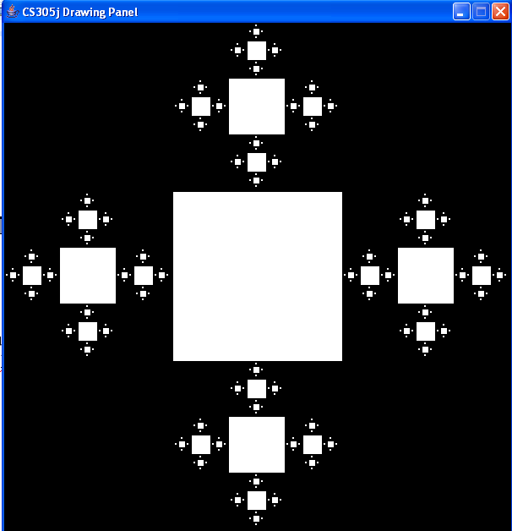

The carpet is drawn via the following algorithm. If the length of the square is greater than some limit divide the square into 9 subs squares in a 3 by 3 grid. Cut out the middle square and then perform the same algorithm on the squares above, below, to the left, and to the right of the middle square. (In the true Sierpinski Carpet this is done to all 8 remaining sub square but to simplify the problem we are only doing 4 sub squares.)

cut out
draw
draw
draw
draw
0, 0

The middle square is "cut out" by drawing a rectangle colored white.

I have provided the starter method. You must supply the method to complete the carpet. You must determine what parameters this method needs and what the initial call to the method would be.

You will need to use the fillRect method from the Graphics class. Here is its signature.

fillRect(int x, int y, int width, int height)
Fills the specified rectangle.

Recall point 0, 0 is at the top, left of the drawing panel and y increases as you go down (not up).
Here is the starter method

// The example shown was produced with a size of 600 and a limit of 1
public static void draw(int size, int limit){
DrawingPanel p = new DrawingPanel(size, size);
Graphics g = p.getGraphics();
g.setColor(Color.BLACK);
g.fillRect(0,0,size,size);
g.setColor(Color.WHITE);
drawSquares(....); // You must determine the parameters for this method
}

Complete your method below and indicate the first call the method from draw.
// Scratch Paper
Name:_______________________________

TAs name: ___________________________

Answer sheet for question 1, short answer questions

- _______________________________
- _______________________________
- _______________________________
- _______________________________
- _______________________________
- _______________________________
- _______________________________
- _______________________________
- _______________________________
- _______________________________
- _______________________________
- _______________________________
- _______________________________
- _______________________________

- _______________________________

