CS 329E
Final: Fall 2005

Name: _____________________________________________________

Place your answers on this exam.

1. (3 points) Consider the following LabVIEW program. What would the output of the multiplication operator be?

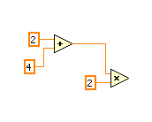

2. (3 points) Consider the following LabVIEW program. What would the output of the addition operator be?

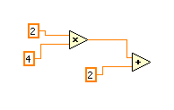
3. (3 points) Consider the following LabVIEW program. What will appear in the result indicator when the program is run?

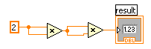
4. (4 points) Consider the following LabVIEW program. Broken wires indicate a problem with the program. Explain the problem.

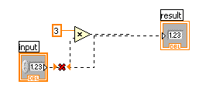
5. (3 points) 1 mile is equal to 1.61 kilometers. Does the following program correctly convert the input in miles to kilometers? If not, explain why not.

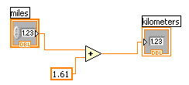

6. (5 points) Explain how the thickness and colors of wires in LabVIEW programs give visual cues to help understand a program.

7. (5 points) Explain the purpose of SubVIs in LabVIEW and methods and functions in Alice and how they are similar.

8. (3 points) Function is LabVIEW can have multiple inputs and multiple outputs. For example consider the Decimate Array Function shown below. It has one input, but can have 2 or more outputs. Did functions we studied in Alice have the ability to return 2 or more values?

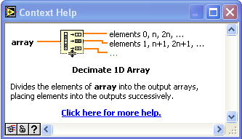

9. (5 points) Describe what the following LabVIEW program does and what kind of output it produces.

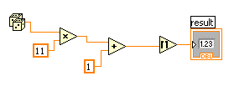
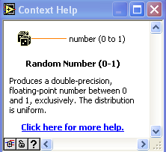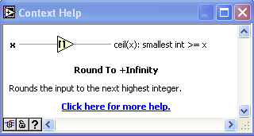

10. (5 points) Given a constant acceleration in one dimension, a, an initial velocity, v, initial position, x0, and time elapsed t, the formula for current position, x is:

x = x0 + v * t + 0.5 * a * t²

Does the following LabVIEW program correctly implement this formula? If not, explain why not.

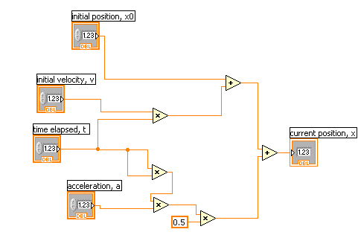

11. (5 points) The program in question 10 is rather complicated. What alternatives exist in LabVIEW for working with complicated formulas?
12. (5 points) A program has a logic error if it runs, but does not do what the programmer intended. Describe why logic errors are generally easier to detect in Alice programs than in LabVIEW programs.

13. (5 points) Describe two built in tools in LabVIEW to assist in debugging programs.

14. (5 points) Explain how colors are represented on computers.

15. (5 points) Describe what the following LabVIEW program does.

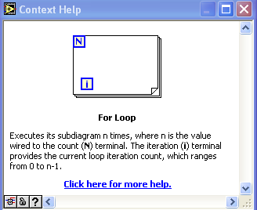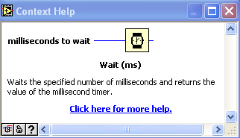

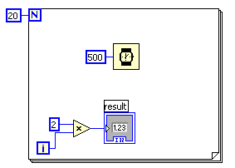
16. (3 points) Explain the purpose of shift registers in loops in LabVIEW.

17. (5 points) Explain what the following LabVIEW program does when run. The while loop is set to “continue if true”.

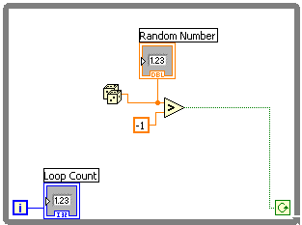

18. (5 points) Describe what case structures are used for in LabVIEW.

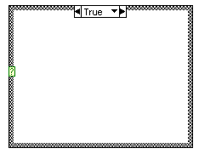

19. (2 points) What types of input may be used on case structures?

20. (3 points) Describe what an array is.

21. (5 points) Consider the following LabVIEW program. Explain why the wire from the array becomes thinner inside the for loop?

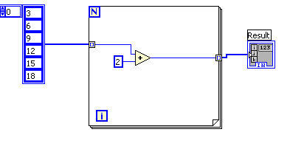
22. (5 points) When the LabVIEW program in question 21 is run, what is the output of the array in the Result indicator?

23. (3 points) What is a cluster in LabVIEW?

24. (5 points) Describe how a color image in LabVIEW can be converted to a gray scale (black and white) image.

