CS 329E
Midterm: Fall 2005

Name: _____________________________________________________

Place your answers on this exam.

1. (10 points) Given the initial scene shown below, where a penguin is facing a cube. The penguin is 2 meters away from the cube. From the penguins point of view, she can see a sphere to the left of the cube and a cone to the right of cube. The sphere and the cone are each 2 meters away from the cube. Describe what happens when the code is run and what the scene looks like when the code is completed.

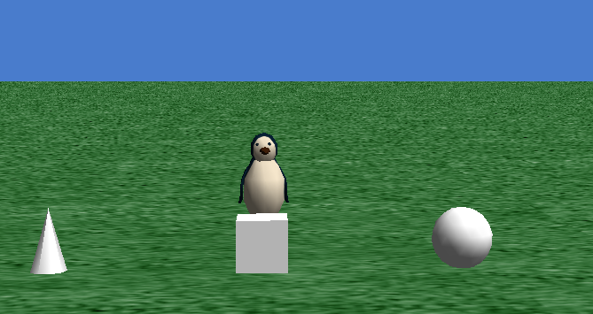

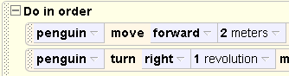

2. (5 points) Given the same initial scene as question 1 and the following block of code. describe what happens when the code is run and what the scene looks like when the code is completed.

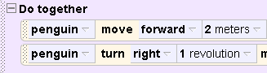

3. (5 points) Given the same initial scene as question 1, describe what the scene looks like after running the following block of code. Specifically state what shape the penguin is closest to and what the penguin is facing.

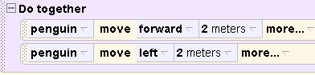
4. (5 points) Given the same initial scene as question 1 and the code block from
question 3. ( Do together – (move forward and move left) ). Would the end result be different if a Do In Order Block were used instead of a Do Together block?

5. (10 points) Consider the following initial scene. The chicken’s vehicle has been set to the cow. The cow’s vehicle is the world.

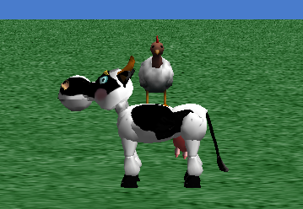

A. (5 points) What happens to the chicken if the cow is moved forward 2 meters?

B. (5 points.) What happens to the cow if the chicken is moved forward 2 meters?
6. (10 points) Consider the following initial scene and code. Draw the path the penguin will move as seen from directly above the penguin. For example if she moves around in a single circle, draw a circle. Use arrows to indicate the direction of motion. Example:

The cone and sphere are initially oriented the same as the penguin.

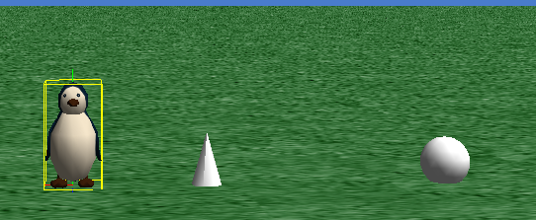

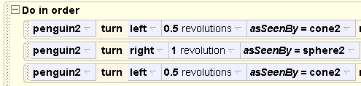

7. (5 points) Consider the following scene, code for the method function World.closer, and a call to the function. The cow is standing between a penguin and a chicken. What value would the call to the function World.closer return?

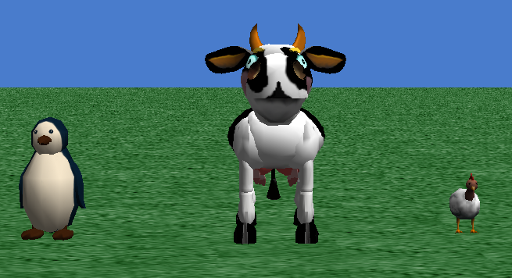

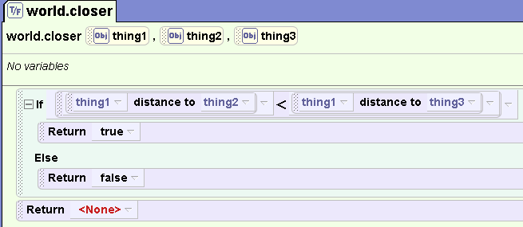

8. (5 points) Using the same initial scene as question 5, what would the expression below evaluate to?

9. (5 points) Using the same initial scene as question 5, what would the expression below evaluate to?

10. (5 points) Consider the code shown below. What is the total distance the penguin moves forward when the code is run?

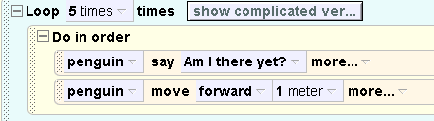

11. (5 points) Consider the code shown below. What is the total distance the penguin moves forward when the code is run?

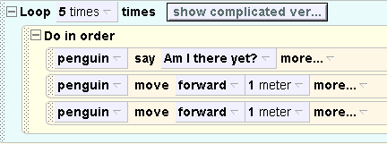

12. ( 5 points) Consider the code shown below. What is the total distance the penguin moves forward when the code is run?

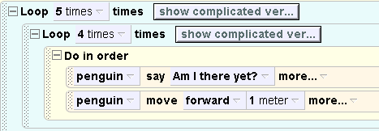

13. (10 points) Consider the following scene and code. The penguin is 10 meters away from the chicken and is facing it. Describe what will happen when the code is run?

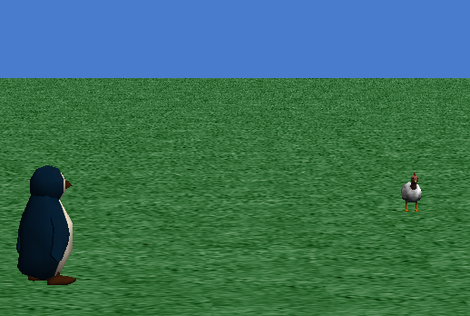

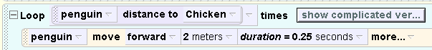

14. (10 points) Consider the same scene as question 13 and the following scene and code. The penguin is 10 meters away from the chicken and is facing it. Describe what will happen when the code is run?

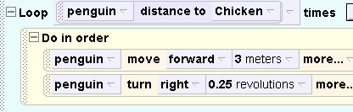

15. (5 points) Consider the same initial scene as question 13 and the following code that has a while loop in it. Is the while loop guaranteed to eventually end? Explain why or why not.

